The Modern Taxila
India’s First Hydrogen Train
Prime Minister Narendra Modi flagged off India's first hydrogen-powered train, on 17th July 2026, developed under the Make in India initiative. The 10-coach, zero-emission train operates on the 89-km Jind-Sonipat section in Haryana, generating electricity onboard via hydrogen fuel cells.
Here is an overview of the historic project:
- Route: Jind and Sonipat, stopping at 12 intermediate stations.
- Technology: Uses hydrogen fuel cells that generate electricity through a chemical reaction between hydrogen and oxygen, emitting only water vapour and heat.
- Capacity: Can accommodate around 2,600 passengers.
- Speed: Operates at a maximum operational speed of 75 km/h, with a design speed of 110 km/h.
- Fares: Highly affordable, ranging from ₹5 for the shortest distances to a maximum of ₹25.

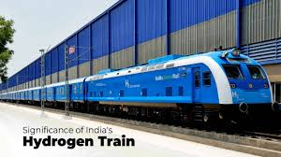

Md. I.A Khan

